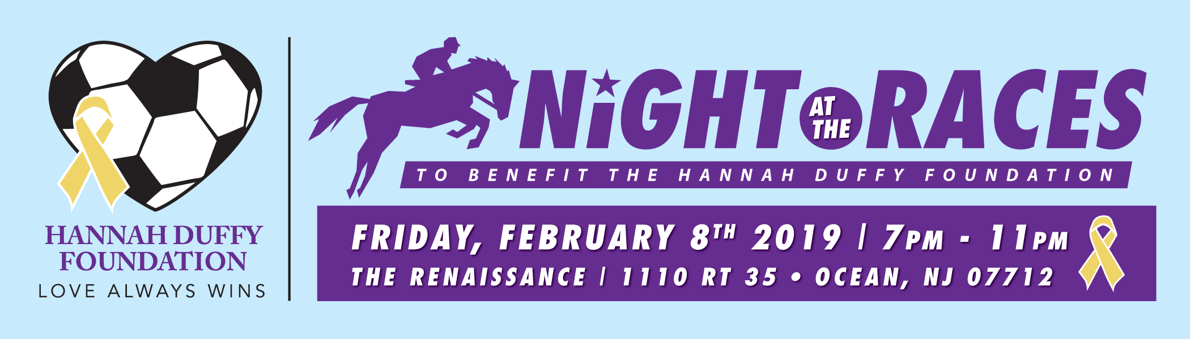

SPONSORSHIP OPPORTUNITIES
ALL SPONSORSHIPS INCLUDE EVENT SIGNAGE AND RECOGNITION

[ ] COVER SPONSOR - $1,000 (3 available) [ ] SPONSOR A RACE - $500 (10 available)
COLOR FULL-PAGE PROGRAM COVER AD, FULL-PAGE AD ADJACENT TO RACE ENTRIES
TABLE SPONSOR + 4 GUEST TICKETS PAGE, TABLE SPONSOR + 2 GUEST TICKETS

JOURNAL ADS

Advertise in the Program

[ ] FULL-PAGE AD (3.75”w x 10.5”h)………………………….…………………..……$250
[ ] HALF-PAGE AD (3.75”w x 5.125”h)…………..……………………………………...$150
[ ] QUARTER-PAGE or BUSINESS CARD AD (3.5” x 2”)……………………………..$ 75
[ ] FAMILY SPONSOR (Include your Name in our Race Program)……..……….…….. $ 50
I AM UNABLE TO ATTEND, BUT PLEASE ACCEPT MY CONTRIBUTION OF: $
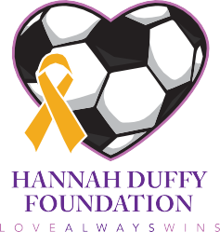
Note: Please email a copy of your ad to: nightattheraces@hannahduffy.org. Please contact Susan Funck at (732) 595-1393 with any questions.
HANNAH DUFFY FOUNDATION | PO Box 873, Eatontown, NJ 07724 | 732-595-1393
www.hannahduffy.org | www.facebook.com/hannahduffyfoundation
THANK YOU! Hannah Duffy Foundation is a recognized 501c(3) tax-exempt organization (Tax ID# 47-1308424).
Your contribution is tax-deductible to the extent permitted by law.
OPTION 2: PAY ONLINE AT
www.hannahduffy.org
OPTION 1: PAY BY CHECK
Please make check payable to the Hannah Duffy Foundation, and mail to PO Box 873, Eatontown, NJ 07724
EMAIL
PHONE
ZIP CODE
STATE
BUSINESS / FIRM ADDRESS
CITY
TITLE
NAME

